Growth Curve Modeling in Stata

What is growth curve modeling (GCM)?

* A model to describe and explain an individual’s change overtime.
* Example research questions:
  + What are the patterns of change for individuals over time?
  + What accounts for the difference in the patterns of change over time?
* Data requirement:
  + Panel data
  + Three-wave panel data: linear growth curve model
  + Four wave panel data: both linear and curvilinear growth curve models

Advantages of GCM:

* Examine several time points, not only the end point in time
* Two main functions:
  + Model **intra-individual** change: intra-individual change refers to the change of the outcome variable for the same individual over time
    - Whether the trajectory is a linear, curvilinear, cubic, or other functional form. Trajectory – used to describe the patterns of change for individuals over time
    - Whether the parameters defining the trajectory have significant variations
  + Explain **inter-individual** differences in the intra-individual trajectories
    - Time-invariant variables, such as sex, race, father’s education
    - Time-variant variables, such as age, education, marital status, place of residence

Disadvantages of GCM:

* At least 3 waves of panel data
* Outcome variables should be measured the same way across waves
* Dataset need to have a time variable
* Researchers need to decide the functional form to predict the outcome variable combining theoretical and empirical evidence

Graphs of trajectory:

* A linear trajectory

𝑌 = 4 + 0.05 ∗ 𝐴ge + σ

* A curvilinear trajectory

𝑌 = 4 + 0.05 ∗ 𝐴ge + 0.03 ∗ Age2 + σ

* A cubic trajectory

𝑌 = 4 + 0.05 ∗ 𝐴ge + 0.03 ∗ Age2 + 0.0001∗Age3 + σ

Graphs of inter-person differences in trajectories:

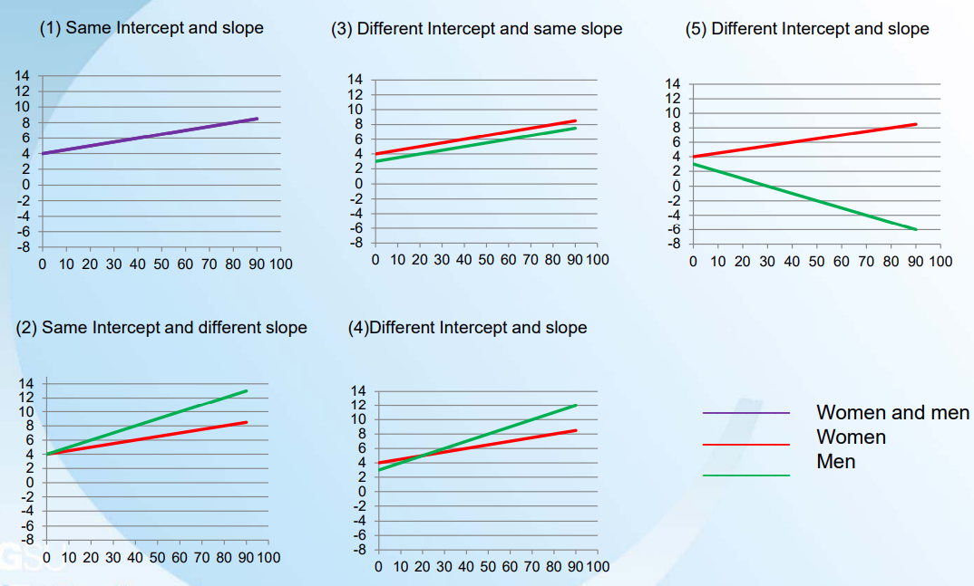

Key concepts of GCM:

* Trajectory is a function of time.
* Trajectory can take on different functional forms (e.g., linear, curvilinear, cubic, and other forms).
* Trajectory describes whether individuals change over time (Intra-individual change) and how fast they change.
* Higher-order functional forms are specified by more parameters.
* The question of why people have different trajectories is equivalent to testing whether people with different attributes have different trajectories (i.e., inter-individual differences in the intra-individual change).

References:

Wu Hsueh-Sheng, CFDR Workshop Series. February 12, 2018.

Michael Bader. Foundations of Growth Curve Models. Epidemiology Summer Workshop. June 22, 2022.